Integrated Groundwater Management: Addressing Climate Change, Politics and the Resultant Metal Contamination and Health Outcomes
Anita Taylor¹- Leili Abkar² – Edward McBean¹

Anita Taylor, M.Sc.
¹Department of Engineering,
University of Guelph,
Email: ataylo69@uoguelph.ca
ORCID ID: 0000-0002-1502-0077
Leili Abkar, Ph.D.
²Adjunct Professor,
Department of Process Engineering,
Dalhousie University,
Email: abkar@dal.ca
ORCID ID: 0000-0001-6464-4110
Edward McBean, Ph.D. P.Eng.

¹ Professor,
Department of Engineering,
University of Guelph,

Email: emcbean@uoguelph.ca

ORCID ID: 0000-0002-4701-5467

Graphical Abstract (my suggestion is to have the arrows regarding climate drivers should be demonstrated as impacting groundwater so arrows down)
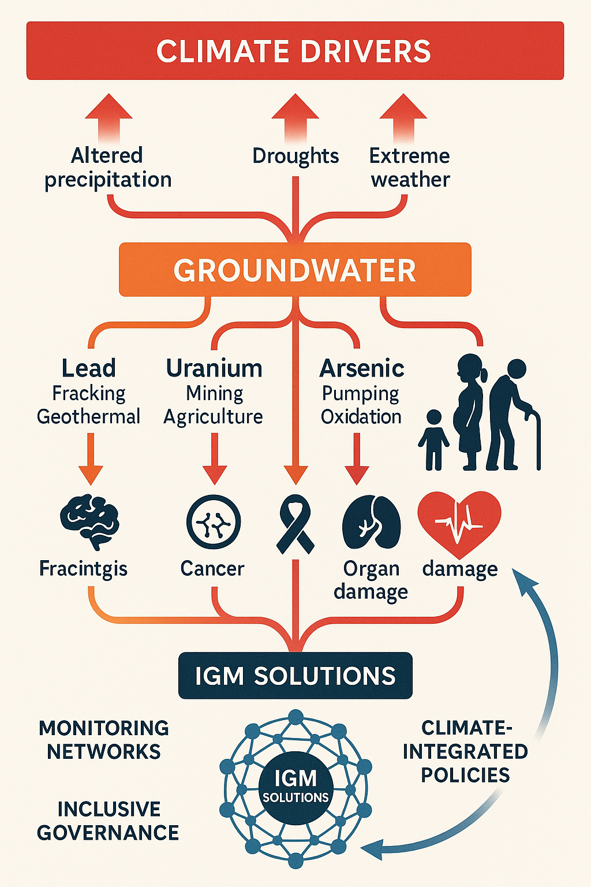

Abstract
Climate change has the potential to increase heavy metal contamination in groundwater, posing severe public health risks through altered hydrological and geochemical dynamics. Current frameworks of Integrated Groundwater Management (IGM) prioritize quantity metrics such as extraction rates when it comes to climate resilience while neglecting quality issues, creating regulatory blind spots for climate induced mobilization of contaminants such as lead, uranium, arsenic, and manganese. These metals, mobilized by climate-driven shifts in precipitation, temperature, and extreme weather, have the potential to cause neurodevelopmental disorders, cancers, and organ dysfunction, resulting in disproportionate impact to vulnerable populations such as children, pregnant women, and the elderly. This review analyzes contaminant pathways, health impacts, and governance challenges, cognitive biases and stakeholder conflicts that IGM procedures can be extended to manage metal contamination caused by climate change .Thus allowing IGM concepts to better identify needs, provide safeguards for groundwater resources and protect public health amid accelerating climate-driven metal mobilization.
Keywords: heavy metal contamination, groundwater quality, public health, water-energy nexus, health equity, vulnerable populations, MAR
Highlights
- IGM frameworks overlook changes in groundwater quality, exacerbating climate-driven metal contamination.
- Lead, uranium, arsenic, and manganese cause severe health risks, amplified by synergistic effects.
- Climate change mobilizes metals through altered precipitation and extraction patterns which becomes amplified by climate driven water changes in the water-energy nexus, agriculture, mining and extraction.

- Inclusive governance and standardized monitoring can enhance water security as conflicts between stakeholders will intensify with water insecurities.

Introduction
Groundwater stores, comprising up to 90% of readily available freshwater, is a critical resource increasingly threatened by climate change and contamination [1]. Even without climate impacts, Groundwater management is inherently a ‘wicked’ problem, involving multiple stakeholders with conflicting goals, evolving systems, and uncertainties from limited data and knowledge [2]. While integrated Groundwater Management (IGM) aims to balance economic, social, and ecological needs, the focus in IGM is on water quantity parameters, such as aquifer depletion and extraction limits, neglecting water quality issues such as heavy metal contamination [3]. Climate-induced changes in precipitation patterns, temperature regimes, and extreme weather events have the capability to mobilize geogenic and anthropogenic metals, including lead, uranium, arsenic, and manganese, which pose risks of neurodevelopmental disorders, cancers, and organ damage [4]. These impacts disproportionately affect vulnerable populations, such as children, pregnant women, and low-income communities, causing exacerbating health inequities [5] .
Traditional groundwater frameworks emphasize extraction rates and water balances, creating regulatory blind spots for contaminants that require specialized monitoring and remediation [6]. Climate change intensifies these challenges by altering groundwater dynamics, increasing reliance on aquifers, and mobilizing previously stable metal deposits[4]. Conflicts over key societal IGM aspects such as the water-energy-agriculture nexus further complicates management, including stakeholder conflicts and cognitive biases—reductionism, dogmatism, and managerialism— which undermine effective governance [7]. In response, this review expands important IGM’s concepts to climate affected water quality, by analyzing metal contamination pathways, and assessing health impacts across vulnerable populations. Transdisciplinary strategies, quality metrics and inclusive stakeholder engagement mentioned in IGM can be extended to water quality. Thus expanding IGM to enhance to water security and protect public health with a changing climate. Figure 1 illustrates the interconnected groundwater issues and policy sectors shaping IGM [3].
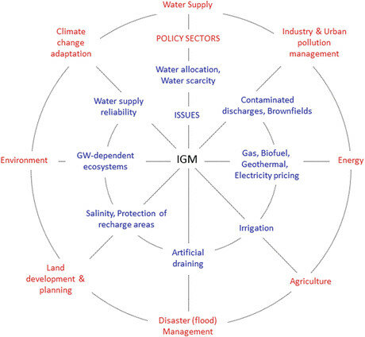
Figure 1: Map of interconnected groundwater issues and policy sectors, illustrating the complexity of IGM across water, energy, and agriculture domains [3]

Governance Challenges in IGM
The governance dimension consistently presents the primary barrier to effective IGM. It requires coordinated collective action to control, protect, and sustainably use groundwater resources through legal frameworks, policies, financing, and sustainability awareness [3]. Kaufmann-Hayoz et al. (2001) identifies five governance tools: government command and control measures, economic instruments like taxes or water markets, collaborative stakeholder agreements, communication tools to influence behavior and attitudes, and infrastructure investments [8]. These can be utilized not just to preserve water quantity but also water quality with climate change impacts.
Effective IGM requires overcoming governance challenges rooted in cognitive biases and stakeholder conflicts. Reductionism, dogmatism, and managerialism hinder holistic management, particularly in addressing climate-driven metal contamination [7]. Reductionism oversimplifies groundwater systems, ignoring interconnections within the water-energy-agriculture nexus [9]. Dogmatism prioritizes dominant perspectives, marginalizing small-scale farmers and vulnerable communities. Managerialism overlooks intervention limitations, such as outdated “safe yield” definitions that neglect ecosystem impacts [10].
Table 1 summarizes these challenges and proposed solutions. Stakeholder conflicts, such as industrial overuse in northwestern India, deplete aquifers and introduce uranium via geochemical interactions and fertilizers [11]. Secretive groundwater economies, such as unreported wells in Algeria, evade regulation [12]. Transboundary aquifers such as those between Syria and Turkey face conflicting withdrawal standards [10]. Institutional fragmentation, unstandardized databases and limited public data hinder predictive modeling and policy development [12] .

Table 1: Governance Challenges and Proposed Solutions
Challenge | Description | Governance Tools Affected | Proposed Solution
Reductionism | Oversimplifies nexus interactions | Economic instruments | Cross-sectoral coordination
Dogmatism | Marginalizes small stakeholders | Collaborative stakeholder agreement | Inclusive engagement
Managerialism | Ignores intervention limits | Government command and control measures | Updated metrics (e.g., ecosystem health)
Data Gaps | Unstandardized, limited access | Infrastructure investments | Standardized, interoperable databases
Stakeholder Conflict | Industrial vs. agricultural overuse | Communication tools | Equitable cost-sharing (e.g., contingent valuation)
This returns to fundamental questions that exposes deep stakeholder conflicts such as what constitutes sustainable long-term groundwater pumping, and what ecosystem tradeoffs are acceptable? Climate change intensifies these unresolved disputes, leading to overexploitation, depletion, and secondary arsenic contamination.
Some case examples where this is empathised is with Arsenic. Arsenic becomes water-soluble through oxidation (arsenite to arsenate) when groundwater levels drop, entering aquifers through altered flow patterns and human activities like pumping and landfills [13]. Originally concentrated in India, Bangladesh, and China's Bengal delta, arsenic contamination now affects Myanmar, Cambodia, Europe, the United States, and Australia [4].
Pumping influences arsenic mobilization through multiple pathways: water table lowering causes oxidation, drawdown mobilizes previously mineralized arsenic, and altered flow patterns mix waters from different aquifer sections [14,15]. Well depth, operation patterns, and positioning within hydraulic gradients all affect contamination levels—factors that climate change will modify as communities increasingly rely on deeper, slower-recharging aquifers [16].
Since geogenic arsenic contamination spans large areas and cannot be remediated at the source, integrated groundwater management becomes critical for balancing competing stakeholder demands while protecting human health and managing economic costs[15]. Figure 2 illustrates pumping impacts on ecosystems, highlighting governance gaps [24].
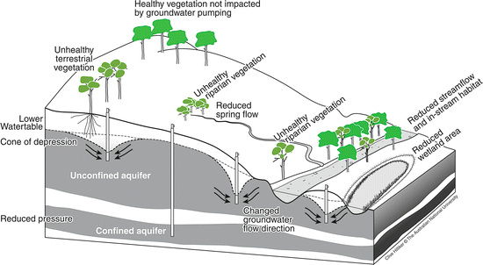
Figure 2: Impacts of groundwater pumping on ecosystems, highlighting governance gaps in sustainable extraction [17].
IGM policy frameworks must address these gaps by extending inclusive engagement, standardized protocols, and equitable cost-sharing models, such as the contingent valuation method to not only protect groundwater quantity but add in quality measures [10].

Climate Change and Groundwater Quality
As previously stated, climate change has the capability to significantly alter groundwater quality by mobilizing heavy metals through hydrological and geochemical changes. Shifts in precipitation patterns, rising temperatures, and extreme weather events disrupt aquifer dynamics, increasing contaminant exposure risks [4]. Reduced recharge during droughts heightens reliance on groundwater, by lowering water tables and altering geochemical conditions that release metals such as arsenic and uranium [18,19]. Further, flooding and saltwater intrusion, exacerbated by sea-level rise, introduces anthropogenic pollutants and can mobilize geogenic metals in coastal aquifers [20,21].
Table 2 summarizes the pathways and sources of key metal contaminants, highlighting climate’s role in their mobilization. Increased groundwater extraction, driven by surface water scarcity, accelerates metal mobilization. For example, overpumping can oxidize aquifer sediments, releasing arsenic in regions such as the Bengal Delta [22]. Temperature rises enhance microbial activity, altering redox conditions and increasing manganese solubility [23]. Extreme weather events, such as hurricanes, can disrupt infrastructure, introducing lead from aging pipes or industrial runoff [24].

Table 2: Metal Contamination Pathways and Sources
Metal | Geogenic Sources | Anthropogenic Sources | Climate-Driven Mechanism
Lead | Mineral dissolution [25] | Fracking, geothermal piping [26,27] | Drought-induced concentration, flooding [4,28]
Uranium | Rock weathering [29] | Mining, fertilizers [11,16] | Overexploitation, changing geochemistry [29,30]
Arsenic | Sediment oxidation [31] | Landfills, pumping [18,32] | Overpumping, oxidation from low water table [14]
Manganese | Redox-sensitive minerals [33] | Wastewater, recharge [34] | Temperature shifts, redox changes [33]
These processes are compounded within the water-energy-agriculture nexus, where energy-intensive pumping and agricultural runoff introduce additional contaminants [9]. Figure 3 illustrates the water-energy nexus, highlighting how climate-driven water scarcity increases energy demands, further stressing groundwater systems [35].
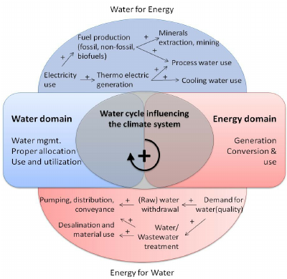
Figure 3: Diagram of the water-energy nexus, highlighting how climate-driven water scarcity increases energy demands, stressing groundwater systems [35]

Water and energy are intrinsically connected through the necessity of energy for water extraction and distribution, and water for energy production processes including cooling, steam generation, and production across all energy sources [36]. Climate change intensifies this relationship—droughts and altered precipitation patterns increase energy demands for water extraction and purification, while rising temperatures require more energy and thus more water, creating a compounding cycle [37,38]. Integrated groundwater management must address both energy production and water reliability while avoiding reductionist approaches that isolate groundwater from energy effects or prioritize single stakeholder perspectives over coordinated solutions.
Metal contamination, particularly lead, exemplifies these interconnected challenges. As energy demand grows, fracking operations introduce more lead into groundwater systems, complicated by limited data on groundwater migration pathways and increased competition for water resources[27]. Geothermal plants, whose stability depends on groundwater levels, may release higher lead concentrations during droughts when subsidence compounds operational stress, as lead exists in construction materials, piping, and geothermal fluids [39,40].
Hydropower facilities face similar challenges—droughts and floods affect capacity and stability while increasing surface water-groundwater interactions near dams under reduced water reserves[41]. These conditions can mobilize anthropogenic lead contamination, demonstrating how climate-driven water stress creates cascading metal contamination risks across multiple energy sectors that require coordinated stakeholder management approaches [42].
By expanding IGM concepts to water quality, managers can develop adaptive strategies to protect groundwater quality and public health under changing environmental conditions.

Metal Contamination Pathways and Health Impacts
Heavy metals—lead, uranium, arsenic, and manganese—can enter groundwater through geogenic and anthropogenic pathways, thereby posing significant health risks. Climate change exacerbates these pathways, amplifying exposure and toxicity.
Lead contamination arises from both anthropogenic sources, such as fracking and geothermal plant piping, and geogenic processes during droughts that concentrate metals in aquifers [25–27] and causes neurotoxic effects, causing cognitive impairments and developmental delays in children [43]. Uranium, introduced via mining, fertilizers, and overexploitation-induced geochemical changes, primarily affects kidneys, increasing chronic kidney disease risk [44] . Arsenic, mobilized by overpumping and oxidation (to arsenate) is a confirmed carcinogen linked to skin, bladder, and lung cancers, with neurotoxic effects in children[45] . Manganese, sensitive to redox changes in managed aquifer recharge, causes neurological impairments resembling Parkinson’s disease [5,46]. Health impacts vary by exposure type: acute (e.g., gastrointestinal issues from short-term exposure), chronic (e.g., organ damage from prolonged exposure), and cumulative (e.g., metal accumulation in tissues) [47] . Synergistic effects amplify risks; for instance, lead and cadmium together enhance kidney damage. Table 3 outlines the health impacts of these metals, emphasizing vulnerable populations.

Table 3: Health Impacts of Metal Contamination
Metal | Acute Effects | Chronic Effects | Synergistic Effects | Vulnerable Populations
Lead | Cramps, headaches [43] | Cognitive impairment, IQ loss [43]. | With copper, Gastrointestinal issues [47] | Children, pregnant women [47]
Uranium | Kidney failure [48] | Kidney damage, cancer risk [48] | With cadmium: increased kidney damage [44] | Infants, Adults, elderly [44]
Arsenic | Skin lesions [45] | Cancers, cardiovascular issues [45,49] | With chromium: lung cancer [49] | Children, elderly [49]
Manganese | coughing, wheezing, and shortness of breath [50] | Neurological deficits[46] | N/A | Infants, elderly [5,46]
Figure 4 illustrates stakeholder motivations driving groundwater use, highlighting how industrial and agricultural activities contribute to contamination [51] .Climate change drives groundwater overexploitation to compensate for altered precipitation, creating metal contamination pathways through increased fertilizer application, mining for adaptive technologies, and industrial reliance on groundwater as surface water becomes unreliable [4,52].
Industrial metal contamination pathways become particularly problematic when companies abandon responsibility [15]. Decades of ignored point and non-point metal pollution from over-extracted aquifers, combined with abandoned mining sites, industrial facilities, and bankrupt companies, create diffuse metal contamination that's difficult to trace. Legacy metal pollution from these sources ultimately forces public institutions to address contamination pathways originally created by private stakeholders who avoided accountability [10].
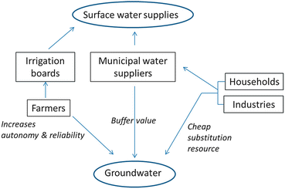
Figure 4: Stakeholder motivations for groundwater use, highlighting industrial and agricultural contributions to contamination [51]

Vulnerable Populations
Heavy metal contamination disproportionately affects vulnerable populations, including children, pregnant women, the elderly, and low-income communities. Children are highly susceptible due to developing physiology; lead and arsenic impair cognitive function, while manganese disrupts brain development [5,46] . Pregnant women face risks of placental metal transfer, causing preterm birth and developmental defects [47] . The elderly, particularly those over 65, experience exacerbated cognitive decline from lead and cardiovascular issues from arsenic[49].
Socioeconomic factors amplify vulnerabilities. Low-income communities often lack access to remediation technologies and healthcare, increasing exposure risks [53]. For example, marginalized farmers in the Mitidja plain in Algeria rely on contaminated groundwater due to limited alternatives [10]. These inequities underscore the need for targeted interventions, such as enhanced monitoring in high-risk areas and subsidized water treatment systems.
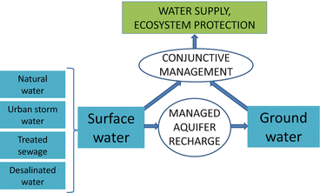
Figure 5: Managed aquifer recharge processes, illustrating potential manganese contamination risks in vulnerable communities [54]

IGM must prioritize health equity by integrating community inputs and health outcome surveillance. Figure 5 illustrates managed aquifer recharge processes which, if mismanaged, can exacerbate manganese exposure in vulnerable communities [54] . Managed Aquifer Recharge (MAR) serves as a climate change adaptation strategy involving deliberate aquifer recharge, but creates complex metal contamination pathways affecting vulnerable populations who rely heavily on groundwater access [55].
MAR infiltration ponds introduce anthropogenic metals via stormwater, mobilizing Mn²⁺ in shallow aquifers through redox-sensitive dissolution under reducing conditions where vulnerable populations access groundwater via hand pumps [54]. Riverbank filtration mobilizes manganese during operation despite geo-purification benefits, contaminating sources accessed by marginalized communities with limited municipal water access [56,57]. Complex hydrogeochemical changes during filtration require further investigation to minimize exposure risks.
Coastal direct injection MAR may reduce manganese contamination by restoring hydraulic gradients against saltwater intrusion, but redox fluctuations from saline mixing create unpredictable metal mobility patterns in community wells [58]. Treated wastewater used for MAR contains residual manganese from insufficient treatment standards, contaminating groundwater accessed by vulnerable populations lacking alternative sources, testing capabilities, or treatment resources, resulting in disproportionate metal exposure from quantity-focused MAR operations [14]. Policies should address systemic barriers, ensuring vulnerable populations are protected from climate-driven contamination.

Conclusion
Most groundwater frameworks exhibit critical deficiencies, prioritizing quantity over quality and failing to address climate-driven heavy metal contamination. Lead, uranium, arsenic, and manganese, mobilized by altered precipitation, increased extraction, and extreme weather, can ultimately pose severe health risks, including neurodevelopmental disorders, cancers, and organ dysfunction. These impacts disproportionately affect vulnerable populations, exacerbating health inequities. Governance challenges, including cognitive biases and stakeholder conflicts, undermine effective management, while data and institutional fragmentation hinder progress. This review highlights the urgent need for incorporation of transdisciplinary IGM approaches involving integration of hydrogeology, toxicology, climate science, and public health. Policy reforms must establish comprehensive monitoring, climate-integrated regulations, and inclusive governance to safeguard groundwater quality. By addressing the climate-metal-health nexus, IGM can protect public health and enhance water security in a changing climate.

Future Research and Gaps
Future research is critical to expand IGM to climate-driven metal contamination. Predictive hydrological models integrating climate projections are needed to forecast metal mobilization under varying conditions. Standardized data platforms and interoperable databases can address current deficiencies, enabling robust modeling and policy development [3]. Investigating synergistic interactions among metals, such as lead-cadmium kidney damage, is essential to quantify cumulative health risks.
Technological gaps include low-cost remediation systems for arsenic and manganese, particularly in low-income regions [10]. Governance research should explore equitable frameworks to include marginalized stakeholders, such as small-scale farmers [22]. Long-term health studies on chronic and synergistic metal exposures can inform regulatory thresholds. Addressing these gaps will enhance IGM’s capacity to mitigate contamination and protect vulnerable populations.

References:
1. UNEP Vital Water Graphics :: An Overview of the State of the World’s Fresh and Marine Waters; UNEP, 2002; ISBN 978-92-807-2236-9.
2. Rittel, H.W.J.; Webber, M.M. Dilemmas in a General Theory of Planning. Policy Sci. 1973, 4, 155–169, doi:10.1007/BF01405730.
3. Jakeman, A.J.; Barreteau, O.; Hunt, R.J.; Rinaudo, J.-D.; Ross, A.; Arshad, M.; Hamilton, S. Integrated Groundwater Management: An Overview of Concepts and Challenges. In Integrated Groundwater Management: Concepts, Approaches and Challenges; Jakeman, A.J., Barreteau, O., Hunt, R.J., Rinaudo, J.-D., Ross, A., Eds.; Springer International Publishing: Cham, 2016; pp. 3–20 ISBN 978-3-319-23576-9.
4. Barbieri, M.; Barberio, M.D.; Banzato, F.; Billi, A.; Boschetti, T.; Franchini, S.; Gori, F.; Petitta, M. Climate Change and Its Effect on Groundwater Quality. Environ. Geochem. Health 2023, 45, 1133–1144, doi:10.1007/s10653-021-01140-5.
5. Rodrigues, E.G.; Kile, M.; Dobson, C.; Amarasiriwardena, C.; Quamruzzaman, Q.; Rahman, M.; Golam, M.; Christiani, D.C. Maternal–Infant Biomarkers of Prenatal Exposure to Arsenic and Manganese. J. Expo. Sci. Environ. Epidemiol. 2015, 25, 639–648, doi:10.1038/jes.2015.45.
6. Elshall, A.S.; Arik, A.D.; El-Kadi, A.I.; Pierce, S.; Ye, M.; Burnett, K.M.; Wada, C.A.; Bremer, L.L.; Chun, G. Groundwater Sustainability: A Review of the Interactions between Science and Policy. Environ. Res. Lett. 2020, 15, 093004, doi:10.1088/1748-9326/ab8e8c.
7. Elsawah, S.; Guillaume, J.H.A. Incorporating Human Aspects into Groundwater Research and Policy Making: A Soft and Critical Systems Thinking Approach. In Integrated Groundwater Management: Concepts, Approaches and Challenges; Jakeman, A.J., Barreteau, O., Hunt, R.J., Rinaudo, J.-D., Ross, A., Eds.; Springer International Publishing: Cham, 2016; pp. 619–637 ISBN 978-3-319-23576-9.
8. Kaufmann-Hayoz, R.; Bättig, C.; Bruppacher, S.; Defila, R.; Di Giulio, A.; Flury-Kleubler, P.; Friederich, U.; Garbely, M.; Gutscher, H.; Jäggi, C.; et al. A Typology of Tools for Building Sustainability Strategies. In Changing Things — Moving People: Strategies for Promoting Sustainable Development at the Local Level; Kaufmann-Hayoz, R., Gutscher, H., Eds.; Birkhäuser: Basel, 2001; pp. 33–107 ISBN 978-3-0348-8314-6.
9. Pittock, J.; Hussey, K.; Stone, A. Groundwater Management Under Global Change: Sustaining Biodiversity, Energy and Food Supplies. In Integrated Groundwater Management: Concepts, Approaches and Challenges; Jakeman, A.J., Barreteau, O., Hunt, R.J., Rinaudo, J.-D., Ross, A., Eds.; Springer International Publishing: Cham, 2016; pp. 75–96 ISBN 978-3-319-23576-9.
10. Fienen, M.N.; Arshad, M. The International Scale of the Groundwater Issue. In Integrated Groundwater Management: Concepts, Approaches and Challenges; Jakeman, A.J., Barreteau, O., Hunt, R.J., Rinaudo, J.-D., Ross, A., Eds.; Springer International Publishing: Cham, 2016; pp. 21–48 ISBN 978-3-319-23576-9.
11. Manoj, S.; Thirumurugan, M.; Elango, L. An Integrated Approach for Assessment of Groundwater Quality in and around Uranium Mineralized Zone, Gogi Region, Karnataka, India. Arab. J. Geosci. 2017, 10, 557, doi:10.1007/s12517-017-3321-5.
12. Kuper, M.; Faysse, N.; Hammani, A.; Hartani, T.; Marlet, S.; Hamamouche, M.F.; Ameur, F. Liberation or Anarchy? The Janus Nature of Groundwater Use on North Africa’s New Irrigation Frontiers. In Integrated Groundwater Management: Concepts, Approaches and Challenges; Jakeman, A.J., Barreteau, O., Hunt, R.J., Rinaudo, J.-D., Ross, A., Eds.; Springer International Publishing: Cham, 2016; pp. 583–615 ISBN 978-3-319-23576-9.
13. Acharya, S.K.; Baidya, P. Arsenic in Groundwater Poison, Man and Ecology; CONTENT VIBES, 2024; ISBN 978-81-976825-4-4.
14. Fakhreddine, S.; Prommer, H.; Scanlon, B.R.; Ying, S.C.; Nicot, J.-P. Mobilization of Arsenic and Other Naturally Occurring Contaminants during Managed Aquifer Recharge: A Critical Review. Environ. Sci. Technol. 2021, 55, 2208–2223, doi:10.1021/acs.est.0c07492.
15. Warner, K.L.; Barataud, F.; Hunt, R.J.; Benoit, M.; Anglade, J.; Borchardt, M.A. Interactions of Water Quality and Integrated Groundwater Management: Examples from the United States and Europe. In Integrated Groundwater Management: Concepts, Approaches and Challenges; Jakeman, A.J., Barreteau, O., Hunt, R.J., Rinaudo, J.-D., Ross, A., Eds.; Springer International Publishing: Cham, 2016; pp. 347–376 ISBN 978-3-319-23576-9.
16. Panda, D.K.; Tiwari, V.M.; Rodell, M. Groundwater Variability Across India, Under Contrasting Human and Natural Conditions. Earths Future 2022, 10, e2021EF002513, doi:10.1029/2021EF002513.
17. Eamus, D.; Fu, B.; Springer, A.E.; Stevens, L.E. Groundwater Dependent Ecosystems: Classification, Identification Techniques and Threats. In Integrated Groundwater Management: Concepts, Approaches and Challenges; Jakeman, A.J., Barreteau, O., Hunt, R.J., Rinaudo, J.-D., Ross, A., Eds.; Springer International Publishing: Cham, 2016; pp. 313–346 ISBN 978-3-319-23576-9.
18. Appleyard, S.J.; Angeloni, J.; Watkins, R. Arsenic-Rich Groundwater in an Urban Area Experiencing Drought and Increasing Population Density, Perth, Australia. Appl. Geochem. 2006, 21, 83–97, doi:10.1016/j.apgeochem.2005.09.008.
19. Fallahati, A.; Soleimani, H.; Alimohammadi, M.; Dehghanifard, E.; Askari, M.; Eslami, F.; Karami, L. Impacts of Drought Phenomenon on the Chemical Quality of Groundwater Resources in the Central Part of Iran-Application of GIS Technique. Environ. Monit. Assess. 2019, 192, 64, doi:10.1007/s10661-019-8037-4.
20. Crawford, S.E.; Brinkmann, M.; Ouellet, J.D.; Lehmkuhl, F.; Reicherter, K.; Schwarzbauer, J.; Bellanova, P.; Letmathe, P.; Blank, L.M.; Weber, R.; et al. Remobilization of Pollutants during Extreme Flood Events Poses Severe Risks to Human and Environmental Health. J. Hazard. Mater. 2022, 421, 126691, doi:10.1016/j.jhazmat.2021.126691.
21. Basack, S.; Loganathan, M.K.; Goswami, G.; Khabbaz, H. Saltwater Intrusion into Coastal Aquifers and Associated Risk Management: Critical Review and Research Directives. J. Coast. Res. 2022, 38, 654–672.
22. Mukherjee, A.B.; Bhattacharya, P. Arsenic in Groundwater in the Bengal Delta Plain: Slow Poisoning in Bangladesh. Environ. Rev. 2001, 9, 189–220, doi:10.1139/a01-007.
23. Bonte, M.; van Breukelen, B.M.; Stuyfzand, P.J. Temperature-Induced Impacts on Groundwater Quality and Arsenic Mobility in Anoxic Aquifer Sediments Used for Both Drinking Water and Shallow Geothermal Energy Production. Water Res. 2013, 47, 5088–5100, doi:10.1016/j.watres.2013.05.049.
24. Fan, X.; Zhang, X.; Yu, A.; Speitel, M.; Yu, X. Assessment of the Impacts of Climat Change on Water Supply System Pipe Failures. Sci. Rep. 2023, 13, 7349, doi:10.1038/s41598-023-33548-7.
25. Wang, S.; Zheng, K.; Liu, Q.; Wang, L.; Feng, X.; Li, H. Galena Weathering in Simulated Alkaline Soil: Lead Transformation and Environmental Implications. Sci. Total Environ. 2021, 755, 142708, doi:10.1016/j.scitotenv.2020.142708.
26. Ramos, Q.; Armienta, M.A.; Aguayo, A.; Cruz, O. Evaluation of the Interactions of Arsenic (As), Boron (B), and Lead (Pb) from Geothermal Production Wells with Agricultural Soils. Ecotoxicol. Environ. Saf. 2021, 211, 111843, doi:10.1016/j.ecoenv.2020.111843.
27. Dustin, M.K.; Bargar, J.R.; Jew, A.D.; Harrison, A.L.; Joe-Wong, C.; Thomas, D.L.; Brown, G.E.Jr.; Maher, K. Shale Kerogen: Hydraulic Fracturing Fluid Interactions and Contaminant Release. Energy Fuels 2018, 32, 8966–8977, doi:10.1021/acs.energyfuels.8b01037.
28. Jarsjö, J.; Andersson-Sköld, Y.; Fröberg, M.; Pietroń, J.; Borgström, R.; Löv, Å.; Kleja, D.B. Projecting Impacts of Climate Change on Metal Mobilization at Contaminated Sites: Controls by the Groundwater Level. Sci. Total Environ. 2020, 712, 135560, doi:10.1016/j.scitotenv.2019.135560.
29. Krupka, K.; Serne, R. Geochemical Factors Affecting the Behavior of Antimony, Cobalt, Europium, Technetium, and Uranium in Vadose Sediments. 2002, doi:10.2172/15004491.
30. Alam, Md.S.; Cheng, T. Uranium Release from Sediment to Groundwater: Influence of Water Chemistry and Insights into Release Mechanisms. J. Contam. Hydrol. 2014, 164, 72–87, doi:10.1016/j.jconhyd.2014.06.001.
31. Biswas, A.; Majumder, S.; Neidhardt, H.; Halder, D.; Bhowmick, S.; Mukherjee-Goswami, A.; Kundu, A.; Saha, D.; Berner, Z.; Chatterjee, D. Groundwater Chemistry and Redox Processes: Depth Dependent Arsenic Release Mechanism. Appl. Geochem. 2011, 26, 516–525, doi:10.1016/j.apgeochem.2011.01.010.
32. Khan, J.; Shrivastava, R.; Gupta, G.; Singh, N.K. Heavy Metal Contamination in Groundwater: Environmental Concerns and Mitigation Measures. In Heavy Metal Toxicity: Environmental Concerns, Remediation and Opportunities; Singh, R.P., Singh, P., Srivastava, A., Eds.; Springer Nature: Singapore, 2023; pp. 139–165 ISBN 978-981-9903-97-9.
33. Zhang, Z.; Xiao, C.; Adeyeye, O.; Yang, W.; Liang, X. Source and Mobilization Mechanism of Iron, Manganese and Arsenic in Groundwater of Shuangliao City, Northeast China. Water 2020, 12, 534, doi:10.3390/w12020534.
34. Oren, O.; Gavrieli, I.; Burg, A.; Guttman, J.; Lazar, B. Manganese Mobilization and Enrichment during Soil Aquifer Treatment (SAT) of Effluents, the Dan Region Sewage Reclamation Project (Shafdan), Israel. Environ. Sci. Technol. 2007, 41, 766–772, doi:10.1021/es060576+.
35. Schlei-Peters, I.; Kurle, D.; Wichmann, M.G.; Thiede, S.; Herrmann, C.; Spengler, T.S. Assessing Combined Water-Energy-Efficiency Measures in the Automotive Industry. Procedia CIRP 2015, 29, 50–55, doi:10.1016/j.procir.2015.02.013.
36. Vinca, A.; Riahi, K.; Rowe, A.; Djilali, N. Climate-Land-Energy-Water Nexus Models Across Scales: Progress, Gaps and Best Accessibility Practices. Front. Environ. Sci. 2021, 9, doi:10.3389/fenvs.2021.691523.
37. Rezaei Kalvani, S.; Pinardi, R.; Celico, F. The Water–Energy Nexus in 26 European Countries: A Review from a Hydrogeological Perspective. Water 2024, 16, 2981, doi:10.3390/w16202981.
38. Heal, K.V.; Bartosova ,A.; Hipsey ,M. R.; Chen ,X.; Buytaert ,W.; Li ,H.-Y.; McGrane ,S. J.; Gupta ,A. B.; and Cudennec, C. Water Quality: The Missing Dimension of Water in the Water–Energy–Food Nexus. Hydrol. Sci. J. 2021, 66, 745–758, doi:10.1080/02626667.2020.1859114.
39. Liu, W. Drilling Technical Difficulties and Solutions in Development of Hot Dry Rock Geothermal Energy. Adv. Pet. Explor. Dev. 2017, 13, 63–69, doi:10.3968/9456.
40. Baba, A.; and Ármannsson, H. Environmental Impact of the Utilization of Geothermal Areas. Energy Sources Part B Econ. Plan. Policy 2006, 1, 267–278, doi:10.1080/15567240500397943.
41. Basilio Hazas, M.; Marcolini, G.; Castagna, M.; Galli, M.; Singh, T.; Wohlmuth, B.; Chiogna, G. Drought Conditions Enhance Groundwater Table Fluctuations Caused by Hydropower Plant Management. Water Resour. Res. 2022, 58, e2022WR032712, doi:10.1029/2022WR032712.
42. Melo, D. de C.D.; Scanlon, B.R.; Zhang, Z.; Wendland, E.; Yin, L. Reservoir Storage and Hydrologic Responses to Droughts in the Paraná River Basin, South-Eastern Brazil. Hydrol. Earth Syst. Sci. 2016, 20, 4673–4688, doi:10.5194/hess-20-4673-2016.
43. Levallois, P.; Barn, P.; Valcke, M.; Gauvin, D.; Kosatsky, T. Public Health Consequences of Lead in Drinking Water. Curr. Environ. Health Rep. 2018, 5, 255–262, doi:10.1007/s40572-018-0193-0.
44. Corlin, L.; Rock, T.; Cordova, J.; Woodin, M.; Durant, J.L.; Gute, D.M.; Ingram, J.; Brugge, D. Health Effects and Environmental Justice Concerns of Exposure to Uranium in Drinking Water. Curr. Environ. Health Rep. 2016, 3, 434–442, doi:10.1007/s40572-016-0114-z.
45. Hopenhayn, C. Arsenic in Drinking Water: Impact on Human Health. Elements 2006, 2, 103–107, doi:10.2113/gselements.2.2.103.
46. Lucchini, R.G.; Guazzetti, S.; Zoni, S.; Benedetti, C.; Fedrighi, C.; Peli, M.; Donna, F.; Bontempi, E.; Borgese, L.; Micheletti, S.; et al. Neurofunctional Dopaminergic Impairment in Elderly after Lifetime Exposure to Manganese. NeuroToxicology 2014, 45, 309–317, doi:10.1016/j.neuro.2014.05.006.
47. Gerhardsson, L. Chapter 28 - Diagnosis and Treatment of Metal Poisoning General aspects∗∗This Chapter Is Based on the Chapter “Diagnosis and Treatment of Metal Poisoning General Aspects” by Lars Gerhardsson and George Kazaantzis in the Fourth Edition of This Handbook. In Handbook on the Toxicology of Metals (Fifth Edition); Nordberg, G.F., Costa, M., Eds.; Academic Press, 2022; pp. 663–684 ISBN 978-0-12-823292-7.
48. Ma, M.; Wang, R.; Xu, L.; Xu, M.; Liu, S. Emerging Health Risks and Underlying Toxicological Mechanisms of Uranium Contamination: Lessons from the Past Two Decades. Environ. Int. 2020, 145, 106107, doi:10.1016/j.envint.2020.106107.
49. Bae, D.-S.; Gennings, C.; Carter, W.H., Jr.; Yang, R.S.H.; Campain, J.A. Toxicological Interactions among Arsenic, Cadmium, Chromium, and Lead in Human Keratinocytes. Toxicol. Sci. 2001, 63, 132–142, doi:10.1093/toxsci/63.1.132.
50. Federal-Provincial-Territorial Committee on Drinking Water Manganese in Drinking Water; Health Canada: Ottawa, Ontario., 2016;
51. Barreteau, O.; Caballero, Y.; Hamilton, S.; Jakeman, A.J.; Rinaudo, J.-D. Disentangling the Complexity of Groundwater Dependent Social-Ecological Systems. In Integrated Groundwater Management: Concepts, Approaches and Challenges; Jakeman, A.J., Barreteau, O., Hunt, R.J., Rinaudo, J.-D., Ross, A., Eds.; Springer International Publishing: Cham, 2016; pp. 49–73 ISBN 978-3-319-23576-9.
52. Green, T.R. Linking Climate Change and Groundwater. In Integrated Groundwater Management: Concepts, Approaches and Challenges; Jakeman, A.J., Barreteau, O., Hunt, R.J., Rinaudo, J.-D., Ross, A., Eds.; Springer International Publishing: Cham, 2016; pp. 97–141 ISBN 978-3-319-23576-9.
53. Casanova, J.; Devau, N.; Pettenati, M. Managed Aquifer Recharge: An Overview of Issues and Options. In Integrated Groundwater Management: Concepts, Approaches and Challenges; Jakeman, A.J., Barreteau, O., Hunt, R.J., Rinaudo, J.-D., Ross, A., Eds.; Springer International Publishing: Cham, 2016; pp. 413–434 ISBN 978-3-319-23576-9.
54. Dillon, P.; Arshad, M. Managed Aquifer Recharge in Integrated Water Resource Management. In Integrated Groundwater Management: Concepts, Approaches and Challenges; Jakeman, A.J., Barreteau, O., Hunt, R.J., Rinaudo, J.-D., Ross, A., Eds.; Springer International Publishing: Cham, 2016; pp. 435–452 ISBN 978-3-319-23576-9.
55. Maliva, R.G. Anthropogenic Aquifer Recharge and Water Quality. In Anthropogenic Aquifer Recharge: WSP Methods in Water Resources Evaluation Series No. 5; Maliva, R.G., Ed.; Springer International Publishing: Cham, 2020; pp. 133–164 ISBN 978-3-030-11084-0.
56. Dillon, P.; Toze, S.; Page, D.; Vanderzalm, J.; Bekele, E.; Sidhu, J.; Rinck-Pfeiffer, S. Managed Aquifer Recharge: Rediscovering Nature as a Leading Edge Technology. Water Sci. Technol. 2010, 62, 2338–2345, doi:10.2166/wst.2010.444.
57. Page, D.; Bekele, E.; Vanderzalm, J.; Sidhu, J. Managed Aquifer Recharge (MAR) in Sustainable Urban Water Management. Water 2018, 10, 239, doi:10.3390/w10030239.
58. García-Menéndez, O.; Renau-Pruñonosa, A.; Morell, I.; Ballesteros, B.J.; Esteller, M.V. Hydrogeochemical Changes during Managed Aquifer Recharge (MAR) in a Salinised Coastal Aquifer. Appl. Geochem. 2021, 126, 104866, doi:10.1016/j.apgeochem.2020.104866.

